Ch 15
Crown-rots & Wilts

Of the fungal pathogens that infect commercial cash crops, none are more devastating than those caused by vascular wilts. Wilting occurs when plants lose turgor pressure in their cells due to a lack of water, which can be triggered by either abiotic or biotic factors (Fig. 1), ultimately leading to total crop failure. Vascular wilt is a general term used to describe the symptom caused by various disease organisms that block the vascular tissue in plants, thereby restricting the flow of water from the roots to other parts of the plant. This chapter will focus on fungal pathogens that are known to cause wilting in Cannabis plants.
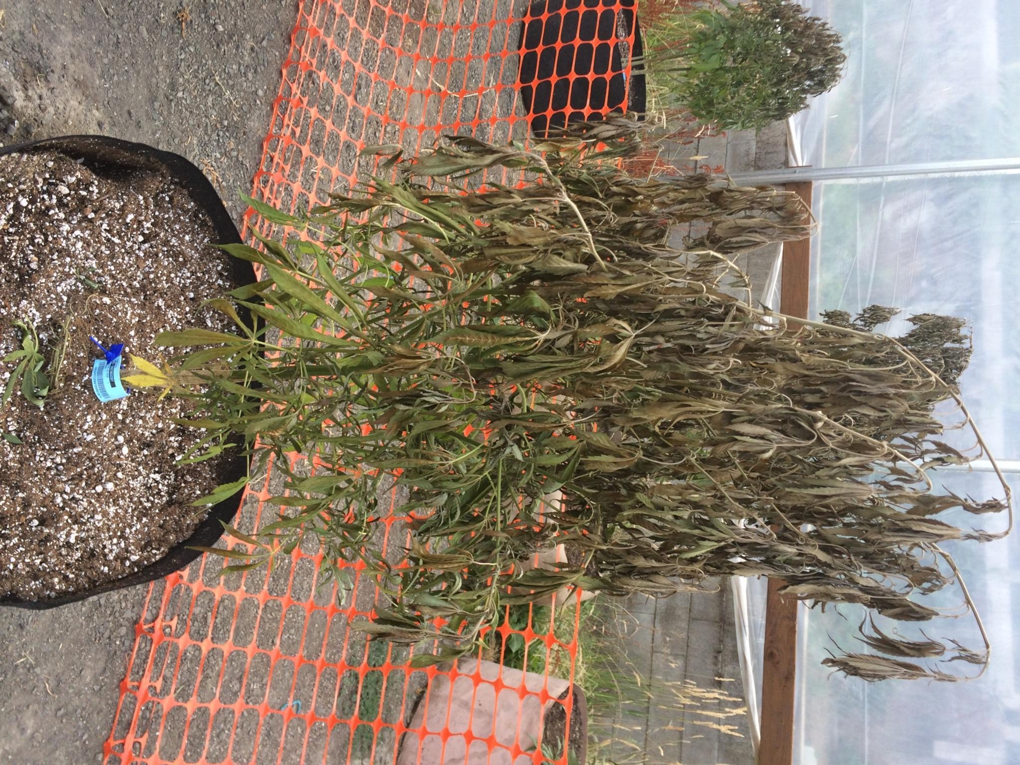
Figure 15.1. Cannabis plant severely affected by Fusarium wilt caused by a Fusarium species.
Vascular wilts are most commonly a concern for large-scale outdoor cultivators. Fusarium is a genus of soil-borne fungi that can cause extensive damage to a wide variety of plants. In particular, Fusarium oxysporum is known to cause wilt in Cannabis. Fusarium is most frequently identified in hemp fields, though this may be due to the widespread cultivation of hemp, which increases the likelihood of encountering this pathogen. Fusarium diseases might also be more prevalent than commonly recognized, as many individuals are unfamiliar with the symptoms and appearance of this pathogen.
Some of the organisms that cause Fusarium wilt in Cannabis can also infect other host plants, so it is important to be aware of the plants growing near Cannabis to minimize the risk of unintentional contamination. Other hosts include coffee, tobacco, alfalfa, and soybeans. Given the rapid spread of these fungi, early identification of the disease is critical for effective management.
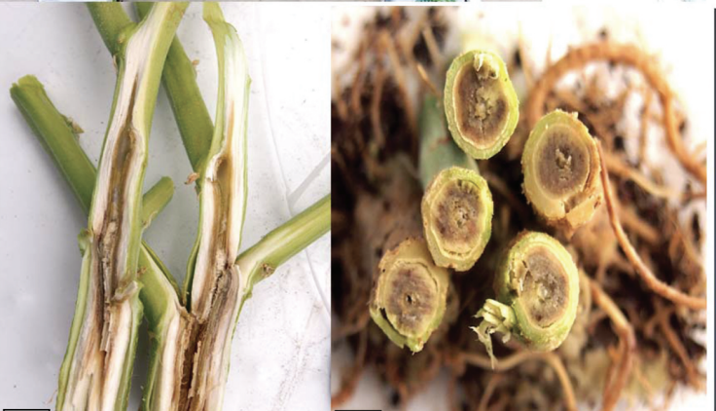

Figure 15.2. Cannabis stalks infected with Fusarium proliferatum which blocks movement of water and nutrients through the vascular system of the plant. (Punja 2020)
of water and nutrients through the vascular system of the plant (Punja 2020).
Symptoms of Fusarium infection are typically characterized by overall wilting of the plant. If the fungus is causing "foot rot," the stems near the soil line may develop a brownish appearance (Fig. 2). Spots will first appear on the lower, more mature leaves. These spots will develop between the leaf veins and spread quickly to newer tissue. Eventually, the leaf tips will curl upward, and the plant will succumb to wilting. Thus, the traditional classification of Fusarium wilt aptly describes the progression of this disease.
In addition to malicious introductions, Fusarium may naturally occur in a region's soil or be dispersed into a garden via wind-borne spores, imported soil, transplant rootballs, or by human activity and equipment. Regardless of its origin, certain environmental conditions promote Fusarium growth, allowing this pathogen to proliferate at an alarming rate.
Punja and Rodriguez (2018) demonstrated that Fusarium oxysporum and F. solani can infect Cannabis roots in a hydroponic system. While infected plants did not always exhibit wilting symptoms, they did show stunted root growth and development. They also noted that plants grown in soil systems exposed to the pathogen were more likely to display typical wilt symptoms. This is due to the more challenging environment for roots to access nutrients, compared to plants grown hydroponically.
Biology & Lifecycle
Fusarium
Fusarium species, classified in the phylum Ascomycota, are soil-borne fungi that produce both sexual and asexual spores. The sexual fruiting body, a structure called a perithecium, and abundant conidia are formed, enabling the fungus to spread and persist. Fusarium can grow saprophytically on dead material and become pathogenic when it encounters a suitable host, such as Cannabis.
Lifecycle:
Fusarium begins its lifecycle with sexual spores or conidia. When a host plant is detected, the fungus grows toward the roots, forming an appressorium to access host tissue. Fusarium invades the xylem, the tissue responsible for water transport, restricting water flow and causing wilting. The fungus produces microconidia that spread via sap flow through the xylem, allowing further colonization of the plant. Fusarium thrives in warm temperatures, with symptoms often appearing once temperatures exceed 26°C (~78°F).
Symptoms:
Fusarium wilt presents as general wilting, with brown discoloration at the soil line, especially in cases of "foot rot." Lower leaves show spots that spread to newer tissue, followed by leaf curling before the plant wilts completely.
Prevention & Treatment:
- Avoid wet, poorly-drained areas to minimize Fusarium growth.
- Excess or insufficient nitrogen fertilization can encourage Fusarium infestation.
- Fusarium requires oxygen to survive, so compact, anaerobic soils are unsuitable for its growth.
- Infected plants should be removed immediately and destroyed (e.g., burning plant debris) to prevent further spread.
- Movement of infected materials, such as soil on equipment or shoes, can carry the pathogen across fields, increasing contamination.
Verticillium:
Verticillium dahliae and V. albo-atrum are also known to cause wilt in Cannabis plants. Verticillium wilt, like Fusarium wilt, is a systemic disease that affects water transport via the xylem, causing wilting. Symptoms include yellowing and wilting leaves, as well as a reddish-brown discoloration in the xylem tissue when the stem is cut.
Verticillium is a genus of soil-borne Ascomycete fungi that can infect Cannabis plants, typically entering through the roots. The fungus is primarily found in soils as microsclerotia (specialized resting structures) or dark hyphae. These structures germinate in response to root exudates and grow toward the plant's root cells. Once inside, the fungus travels through the plant’s vascular system (the xylem), a tissue responsible for water transport, causing the characteristic wilting by blocking the xylem.
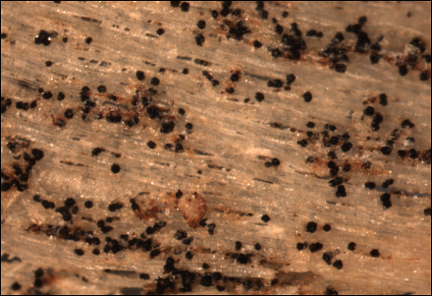
Figure 15.5. Verticillium microsclerotia embedded in woody tissue of Acer spp. Photo credit to N. Brazee

Verticillium spreads through mycelium, conidia, or microsclerotia. When blocked in the xylem, the fungus forms new mycelium around the obstruction, digesting plant tissue and continuing its spread. The fungus proliferates quickly inside the xylem, using conidia for faster dispersal.
After the plant dies, Verticillium acts as a saprotroph, decomposing the dead tissue. The fungus then forms resting structures (microsclerotia or melanized hyphae) within the dead plant’s vascular tissue, allowing it to survive in the soil until the right conditions and host are available. Verticillium dahliae forms more durable microsclerotia and persists in harsh environments longer than V. albo-atrum, which forms less resilient dark hyphal cells.
Prevention and Treatment:
Remediating soil infected with Verticillium is challenging. Traditional chemical treatments, like soil fumigation with Methyl Bromide and Chloropicrin, can reduce pathogen populations but destroy soil health and biodiversity, making it a less desirable solution. Methyl Bromide is highly toxic and can only be used under specific exemptions granted by the EPA.
To manage Verticillium, growers should prioritize good agricultural practices, focusing on soil health and cleanliness. Regular applications of high-quality, biologically active compost can help introduce beneficial microorganisms that protect plants from pathogens. Additionally, planting or breeding resistant Cannabis cultivars can significantly reduce the impact of Verticillium wilt, minimizing crop loss.

Verticillium vs. Fusarium:
- Both wilts have similar symptoms, but Verticillium wilt may also show a "tiger stripe" pattern in leaves.
- Microsclerotia or conidia are often found in the xylem when examined under a microscope.
- Verticillium dahliae is more persistent in soil and affects a wide range of plants like cotton, tomato, and eggplant, while V. albo-atrum has fewer host plants, including hops, a close relative of Cannabis.
Identification and Prevention:
- Accurate identification of Verticillium requires microscopic or molecular techniques.
- Similar prevention methods to Fusarium can be applied, including careful soil management and avoiding contamination from infected plant materials.
Macrophomina
Macrophomina phaseolina, commonly known as charcoal rot, is an Ascomycete fungus responsible for various crop diseases, including vascular wilts. It has an exceptionally broad host range, capable of infecting over 500 different plant species, including Cannabis (Khan, 2007). This pathogen is notorious for causing multiple diseases such as damping off, basal stem rot, root rot, and seedling blight (Ijaz, 2013). While symptoms often resemble other wilt diseases, M. phaseolina can remain latent, only presenting symptoms later in the plant's life (Ijaz, 2013). Notable signs include reduced emergence, severe wilting, yellowing leaves, necrosis, and a general loss of vigor (Kunwar et al., 1986).
A distinct symptom of this infection is the presence of tiny black, tuber-like structures, known as microsclerotia, formed by the fungus, which can be found when the plant stem’s epidermis is peeled off. M. phaseolina is transmitted via soil, roots of transplanted plants, or seed coats (Khan, 2007). Moreover, this fungus poses a potential health risk to humans, particularly immunocompromised individuals (Srinivasan et al., 2009).
Biology & Lifecycle
The lifecycle of M. phaseolina begins with the production of microsclerotia, small, melanized, protective structures that allow the fungus to survive harsh conditions for extended periods (Meyer et al., 1974). These microsclerotia can persist in soil for 2-15 years. When a susceptible plant releases root exudates, the microsclerotia germinate, and the fungus invades the roots.
Once inside the plant, M. phaseolina primarily occupies the intercellular spaces of the root cortex cells (Gupta et al., 2012). Unlike other wilt-causing organisms, it affects the fibrovascular system of the plant, not just the xylem. The fungus can travel through the vascular system, often clogging the tissues, depriving the plant of water and nutrients. This leads to the characteristic "charcoal rot" symptom – black/grey mold in the vascular system.
As the plant dies, M. phaseolina can act as a saprotroph, breaking down dead tissue and leaving behind microsclerotia in the soil, awaiting the next susceptible crop. M. phaseolina produces pycnidia, which are fruiting bodies that house ascospores. These are released when the sacs burst, but they only form under specific conditions, either in certain hosts or in vitro (Gupta et al., 2012, Gaetán et al., 2006).
Prevention and Treatment
Managing charcoal rot is challenging due to the fungus’s persistence in soil. Microsclerotia can survive for long periods, and soil fumigation, though effective, is not always desirable due to its environmental impact (Duniway, 2002). Non-chemical methods, such as crop rotation, soil solarization, and organic amendments that alter the C:N ratio, are recommended (Israel et al., 2005). Maintaining soil health and cleanliness is crucial in preventing the spread of the pathogen.
In cases where M. phaseolina has already infected the field, it is essential to remove infected plants promptly to avoid further contamination. Although chemical antifungals can control the pathogen, their use is controversial due to the broad environmental consequences, and they should only be considered as a last resort.
Developing resistant crop varieties through breeding programs will ultimately reduce yield loss caused by this pathogen, though this will require time and investment in research and development. While M. phaseolina poses a significant challenge to crop health, especially in fields where it persists, practicing good farm management, including crop rotation, soil health improvement, and the cautious use of chemical treatments, can help mitigate its impact.
Athelia rolfsii (formerly Sclerotium rolfsii)
Athelia rolfsii, formerly known as Sclerotium rolfsii, is a particularly damaging fungus that affects Cannabis and many other plant species. The pathogen was initially discovered on a diseased tomato plant in Florida, and it was originally named Sclerotium rolfsii. However, molecular research revealed its sexual stage, leading to its reclassification as Athelia rolfsii. The common name "Southern Blight" stems from its preference for warm climates and its initial discovery in the southern United States.
Athelia rolfsii is a facultative pathogen, meaning it can survive and grow on dead organic matter (acting as a soil saprotroph) when no host plants are present. However, when a susceptible host is available, it infects plants at various stages of growth, causing different symptoms based on the plant's development. For seedlings, it can cause damping-off, whereas for mature plants, it results in wilting or blighting, particularly in the crown or lower stem area. The fungus also produces sclerotia, which helps it survive under harsh environmental conditions, making it difficult to eliminate from infected fields.
Biology & Lifecycle
Athelia rolfsii is a Basidiomycete, making it more distantly related to many other common Cannabis pathogens, which are typically Ascomycetes. The fungus survives in the soil as sclerotia (hard, melanized structures) and vegetative hyphae. The sclerotia can persist in the soil for extended periods, sometimes up to five years, depending on the environmental conditions (Menzies, 1983). These sclerotia germinate when favorable conditions arise, particularly when susceptible plants release root exudates.

Upon germination, the fungus infects plants via direct contact between its hyphae and the roots. The hyphae secrete enzymes that break down plant cell walls before penetrating the cells. Although A. rolfsii is not a systemic pathogen, it causes local lesions at the soil line, which can girdle the stem, kill the root system, and ultimately lead to the death of the plant. Crown rot is a common symptom, where lesions appear on the stem near the soil surface, and white mycelium can be observed growing around the base of the plant.
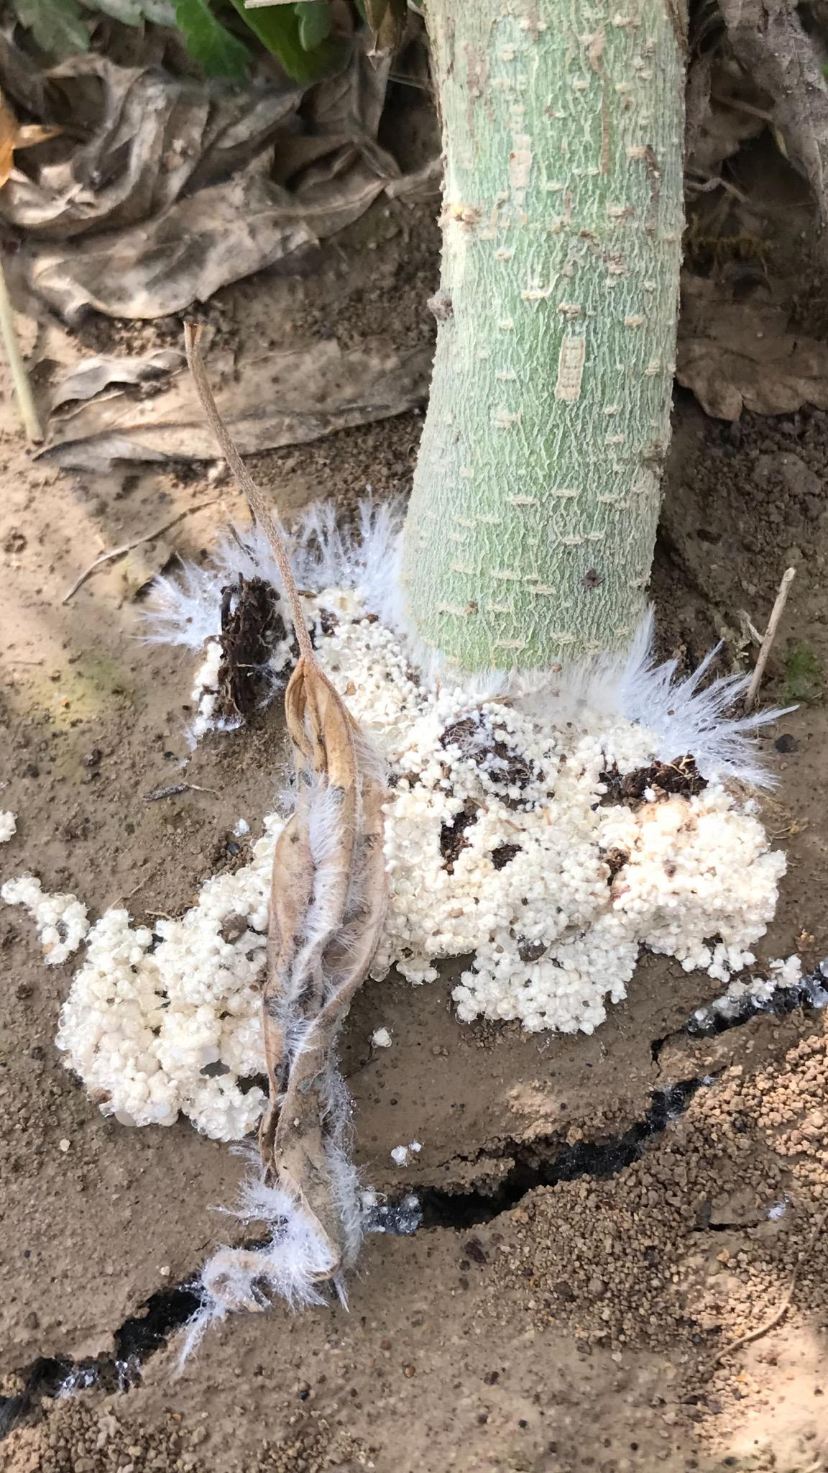
Figure 15. 6 Southern blight causing crown rot with visible mycelium growing where the stem of the plant meets the soil. Photo credit to Dr. N. Gauthier.
Athelia rolfsii is capable of sexual reproduction, but this is rarely observed in natural conditions. Under laboratory conditions, factors like nutrient concentration, light, and culture age can trigger the formation of sexual spores (basidia) on a specialized structure called a resupinate fruiting body, which is a flat, crust-like mat of hyphae (Fig. 9). While sexual reproduction is possible, A. rolfsii predominantly propagates asexually through the production of sclerotia, which can survive in the soil until a suitable host plant is available.
Prevention and Treatment
Athelia rolfsii is difficult to manage once it infects a field, primarily because of its ability to persist in soil as sclerotia for several years. The first defense against Southern Blight is avoiding the use of infected fields and preventing the transfer of inoculum via soil, equipment, or personnel. If an infected plant is identified, it should be removed along with the surrounding soil and incinerated to prevent the spread of the fungus.
Several management strategies can be employed to control Southern Blight:
- Biological Control:
  - Trichoderma species, such as T. harzianium and T. koningii, are effective biocontrol agents. These fungi act as mycoparasites, parasitizing A. rolfsii’s mycelium and sclerotia (Latunde-Dada, 1993). Using Trichoderma in the soil may help reduce the pathogen population, although effectiveness can vary depending on environmental factors (Elad et al., 1984; Punja, 1985).
  - Enhancing soil microbiology by inoculating the soil with high-quality compost may also reduce sclerotia germination, as soil microorganisms can outcompete or inhibit A. rolfsii growth (Punja, 1985).
- Cultural Practices:
  - Crop rotation with non-susceptible plants, such as grasses like corn and switchgrass, may help reduce the pathogen’s presence in the soil (Kator et al., 2015).
  - Good sanitation practices, such as cleaning soil and equipment between crop cycles, can help prevent the spread of sclerotia.
  - Soil solarization can be used in warm climates to kill fungal spores and sclerotia by exposing the soil to high temperatures for extended periods.
- Soil Amendments:
  - High nitrogen applications, particularly those that release ammonia (NH3), may reduce A. rolfsii populations. This could be due to toxic effects on the fungus or a boost in soil microbial activity, which may suppress the pathogen (Faruk et al., 2010).
- Chemical Control:
  - Chemical fungicides are not typically recommended for Southern Blight, as they can disrupt beneficial soil organisms and may be less effective in the long term. They should be considered a last resort after other measures have failed.
- Plant Extracts:
  - Research has shown that Cannabis sativa plant extracts can have activity against A. rolfsii (Faruk et al., 2010). This opens the door for the potential use of Cannabis-derived compounds in managing Southern Blight, although further research is needed to evaluate their efficacy.
Athelia rolfsii (Southern Blight) is a significant threat to Cannabis and many other crops, particularly in warm, moist environments. Its ability to survive as sclerotia in the soil for extended periods makes it a challenging pathogen to manage. However, using a combination of biological control agents, crop rotation, soil amendments, and good field hygiene can help mitigate the impact of this fungus. Breeding resistant Cannabis varieties and exploring natural plant extracts, like those from Cannabis itself, may offer promising avenues for future disease management strategies.
In summary:
- Vascular wilt is another general term used to describe pathogens that causing wilting symptoms in infected plants, caused by various fungal species
- Species in the genus Fusarium are a culpable agents that is a generalist and can infect a number of different host plants
- Verticillium, Macrophomina and Althelia are other common genera that cause wilt
- Spores of fungi that cause vascular wilts can persist in soils for years

